
LAS VEGAS PHILHARMONIC ANNOUNCES
REI HOTODA AS MUSIC DIRECTOR
Acclaimed Conductor Will Lead Las Vegas’ Symphony Orchestra Starting in July 2026
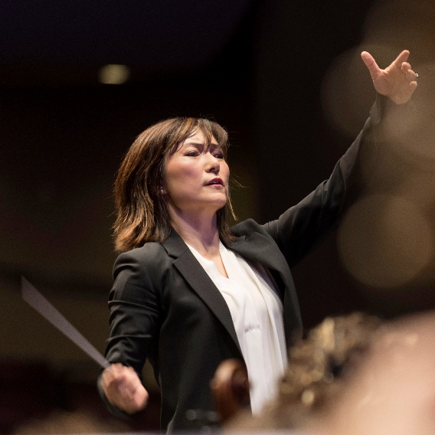
Music Director Designate Rei Hotoda (hi-res image available here)

Las Vegas, NV (November 2, 2025) The Las Vegas Philharmonic announced the appointment of its next Music Director, Rei Hotoda, at last night’s performance to fans and concert goers. Led by Artistic Consultant Leonard Slatkin, the orchestra and audience welcomed Hotoda to the stage and enjoyed a surprise encore - a rousing performance of Bizet’s Les Toreadors from the composer’s Carmen.
“On behalf of the community of Las Vegas, we couldn’t be more thrilled to welcome Rei to our great city and our symphony family,” says Las Vegas Philharmonic Board Chair Jeri Crawford. “In a short time, she has inspired us all and is the ideal choice as the Las Vegas Philharmonic’s artistic trajectory continues.”
Led by a selection committee of board members, orchestra musicians, staff, and community members, the Las Vegas Philharmonic began its search for their next artistic leader in 2024. The expected two-year Music Director search ended midway due to the chemistry between Hotoda, the musicians, board and audience during her appearance leading the Philharmonic from the podium and the keyboard in May 2025.
“This search brought a wide range of musical styles to the Las Vegas Philharmonic patrons and musicians,” says Las Vegas Philharmonic Executive Director Alice Sauro. “Rei was not only a fan favorite, but also incredibly endearing and engaging with our musicians. We are delighted to welcome Rei to Las Vegas as we work to plan the future of this exciting organization and cannot wait to start building the next stage of our philharmonic with her.”
The city’s symphony orchestra will welcome Hotoda to the podium as Music Director Designate to conduct the May performance, Pictures at an Exhibition.
“It is my great pleasure to welcome Rei Hotoda to the Las Vegas Philharmonic family. Her musicianship, ebullient personality and leadership will be a treasure for all,” says Las Vegas Philharmonic Artistic Consultant Leonard Slatkin.
Hotoda will serve as music director for a four-year contract beginning in July 2026. In addition to leading the orchestra from the podium, as Music Director she will collaborate with the administration to develop initiatives that broaden the reach of the institution through audience development and donor stewardship. She will also work closely with staff to create and oversee education programming and special projects. Hotoda will relocate to Las Vegas with her family in the summer of 2026.
Hotoda will announce her first season with the Las Vegas Philharmonic on Valentine’s Day 2026. Subscribers and first time concertgoers can look forward to sharing with her and the Philharmonic a season filled with favorite classics and new discoveries, accessible and affordable to all.

“It is an honor to be appointed Music Director of the Las Vegas Philharmonic. From our first
collaboration, I felt an extraordinary spirit within this orchestra and a genuine connection to its community,” remarks, Rei Hotoda, Music Director Designate of the Las Vegas Philharmonic. “My family and I are delighted to be making Las Vegas our new home, a city brimming with creativity and possibility. I look forward to building on that energy with these remarkable musicians as we shape the Philharmonic’s bright future together.”

The Las Vegas Philharmonic continues to celebrate it is 27th season, with upcoming performances including –
- Bach & Brahms – November 15
- A Very Vegas Christmas – December 6
- Rachmaninoff Concerto No. 3 – January 17
- 1812 Overture – February 14
- The Music of John Williams – March 27 + 28
- Latin Sizzle – April 25
- Pictures at an Exhibition – May 9 - Conducted by Rei Hotoda
* Rei Hotoda is pronounced RAY ho - TOE - dah

ABOUT LAS VEGAS PHILHARMONIC
Celebrating its 27th season in 2025, the Las Vegas Philharmonic enhances the lives of residents and culture of the city through impactful and enlivening performances and events. Under the direction of Artistic Consultant and internationally acclaimed Conductor Leonard Slatkin, the Philharmonic continues to inspire a lifelong appreciation of music through performances and educational experiences for the Las Vegas community. At the orchestra’s core, 76 professional musicians bring depth and variety to the organization. Each season of concerts and performances highlights local talents alongside incredible nationally and internationally recognized guest artists on the magnificent Reynolds Hall stage.
Through music education, The Youth Concert Series, and community engagement programs, The Las Vegas Philharmonic’s commitment to Las Vegas extends from the concert hall to the classroom and beyond. As a 501(c)(3) organization, the Philharmonic’s community, education, and artistic programs are made possible by the generous donations and support of individuals and corporations.
To learn more, visit lvphil.org or call 702.258.5438. Follow the Las Vegas Philharmonic on facebook.com/lasvegasphilharmonic, and X and Instagram @lvphil.
ABOUT REI HOTODA
Rei Hotoda is redefining 21st-century orchestral leadership through bold artistry, innovative collaboration, and a deep commitment to community. Her programs—recognized for their compelling repertoire and advocacy of contemporary American voices—reflect both her creative vision and expressive vitality.

Hotoda is currently the Music Director Designate for the Las Vegas Philharmonic while concurrently serving as the Music Director of the Fresno Philharmonic. Equally at home on the podium and at the piano, she brings a soloist’s insight and versatility to every performance. Hotoda has appeared on the podium leading several illustrious ensembles, including the symphony orchestras of Las Vegas, Chicago, Dallas, St. Louis, Detroit, and San Diego as well as the American Composers Orchestra in her Carnegie Hall debut

Through imaginative programming and cross-disciplinary partnerships, Hotoda is shaping a more inclusive orchestral future. A champion of living composers, she features works by Juan Pablo Contreras, Damien Geter, Jessie Montgomery, and Jerod Impichchaachaaha’ Tate, among many others.

She also serves on the Board of the League of American Orchestras and speaks nationally on equity, innovation, and leadership.

Media Contact – Las Vegas Philharmonic
Authentic Public Relations
Kathryn Palmer // kathryn@authenticpublicrelations.com // 702.325.5049
Savannah Goodall // savannah@authenticpublicrelations.com // 702.286.9509

